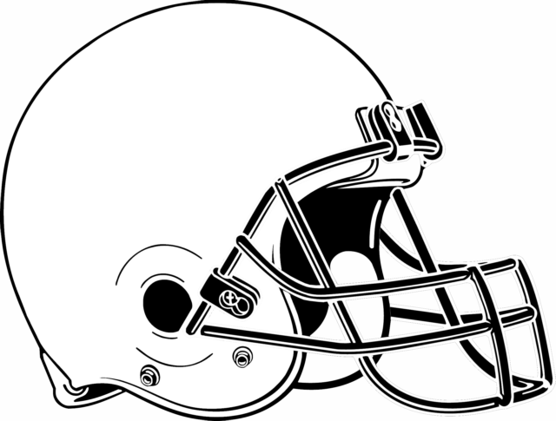

**Product Development Assignment:**

**Creating a Safe Helmet**

In chapter 5 we have discussed the stages of product development in relation to sports products and services. This assignment will give you the opportunity to apply those stages to the creation of a safe sports helmet. Groups of no more than 4.

**Task:**

1. Select a particular sport that requires a helmet to be worn as part of the equipment. (ex: football, hockey, skateboarding, cycling, racing etc)
2. Research what makes a helmet safe for this sport and some of the important considerations in designing any helmet.
3. Complete the product development outline including what materials you will use to create your helmet. **(this will be handed in)**
4. Gather the materials needed and actually create your helmet prototype using the knowledge you have gained from your research. Any helmet made regardless of the sport must include a strap of some kind.
5. Create a brand or team logo to include on your helmet.
6. Create a slideshow to present the development of your helmet. **(presentation)**

* Include any key research that helped in the development
* Discuss the materials that were used and why (include photos of helmet)
* Discuss the development costs and if this is a patented product
* Explain the choice of branding elements
* Discuss why consumers should choose your helmet over others
* Discuss what the selling price of your helmet would be

1. Survive the melon drop **(product testing)**

* All helmets will be dropped using a small/medium ripe melon as the test subject (you bring the melon)
* Do not let that head crack!

**Assignment Guidelines:**

* Hand in your one page product development outline
* Present the development of your helmet using presentation software (powerpoint, prezi etc)
* Create and hand in your helmet prototype including team or brand logo
* Test helmet safety with the melon drop

**Product Development Outline**

|  |
| --- |
| **Step 2: Idea Generation** |
| **Select a group:** _______________________________________________________________________  **Select a sport:** ______________________________ |

|  |
| --- |
| **Step 3: Screening and Evaluation** |
| **Research (include important facts below):** |

|  |
| --- |
| **Step 4: Business Analysis** |
| **Materials List:**  **Create a financial budget and split costs between group members:** |

|  |
| --- |
| **Step 5: Development** |
| **Helmet Prototype:** Create the actual helmet with your group using the materials you have discussed – you must have a strap to hold the melon in place.   * You must have a branded logo that you created on your helmet. * Test the helmets with the melons outside to see how they do!   Include final picture of your helmet here and picture of your logo as well. |

|  |
| --- |
| **Step 7: Commercialization** |
| If you were to bring a final product to market…   1. Selling price and why: 2. Choice of endorser and why: |

**T /20**

**PRODUCT DEVELOPMENT ASSIGNMENT: RUBRIC NAME: _________________________**

|  |  |  |  |  |  |
| --- | --- | --- | --- | --- | --- |
| **Category** | **80-100%**  **(Level 4)** | | **70-79%**  **(Level 3)** | **60-69%**  **(Level 2)** | **50-59%**  **(Level 1)** |
| **Thinking (20 marks)** | | | | | |
| * Use of critical thinking skills to research helmet safety and create a product development plan | Uses critical thinking skills with a high degree of effectiveness | | Uses critical thinking skills with considerable effectiveness | Uses critical thinking skills with some effectiveness | Uses critical thinking skills with limited effectiveness |
| **Application (30 marks)** | | | | | |
| * Use of researched knowledge to create a safe helmet prototype * Helmet design and   creation of helmet logo | Applies ideas and concepts with a high degree of effectiveness  Helmet designed with a high degree of effectiveness | | Applies ideas and concepts with considerable effectiveness  Helmet designed with considerable effectiveness | Applies ideas and concepts with some effectiveness  Helmet designed with some effectiveness | Applies ideas and concepts with limited effectiveness  Helmet designed with limited effectiveness |
| **Communication (20 marks)** | | | | | |
| * Communication of information and ideas * Application of processes and technologies to create a professional multimedia presentation | | Communicates information and ideas with a high degree of clarity  Applies processes and technologies with a high degree of effectiveness and creativity | Communicates information and ideas with considerable clarity  Applies processes and technologies with considerable effectiveness and creativity | Communicates information and ideas with some clarity  Applies processes and technologies with some effectiveness and creativity | Communicates information and ideas with limited clarity  Applies processes and technologies with limited effectiveness and creativity |